1. Agenda:
   1. How to create STUB For POST Endpoint.
2. 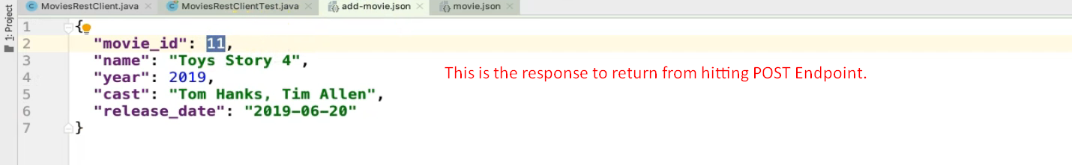
3. 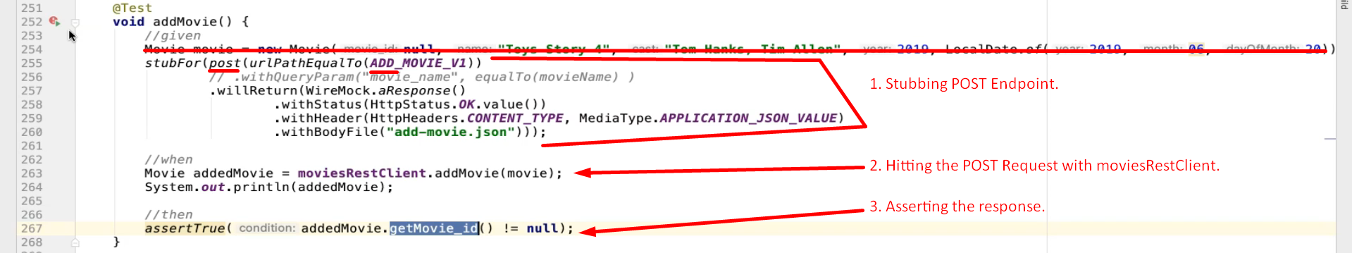
4. 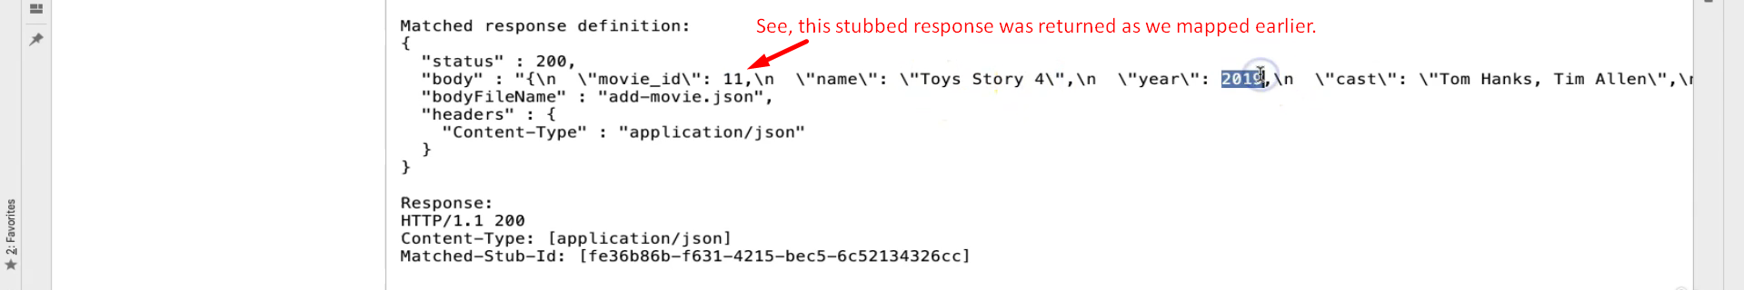
5. Checking if request body in POST contains certain JSON properties without checking their values.   
   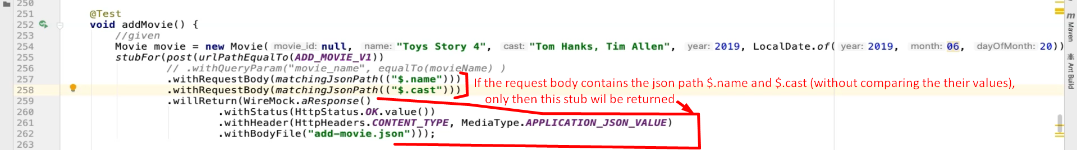  
     
   Checking if request body in POST contains certain JSON properties without checking their values. If any of them is not found in request body, then no match.  
   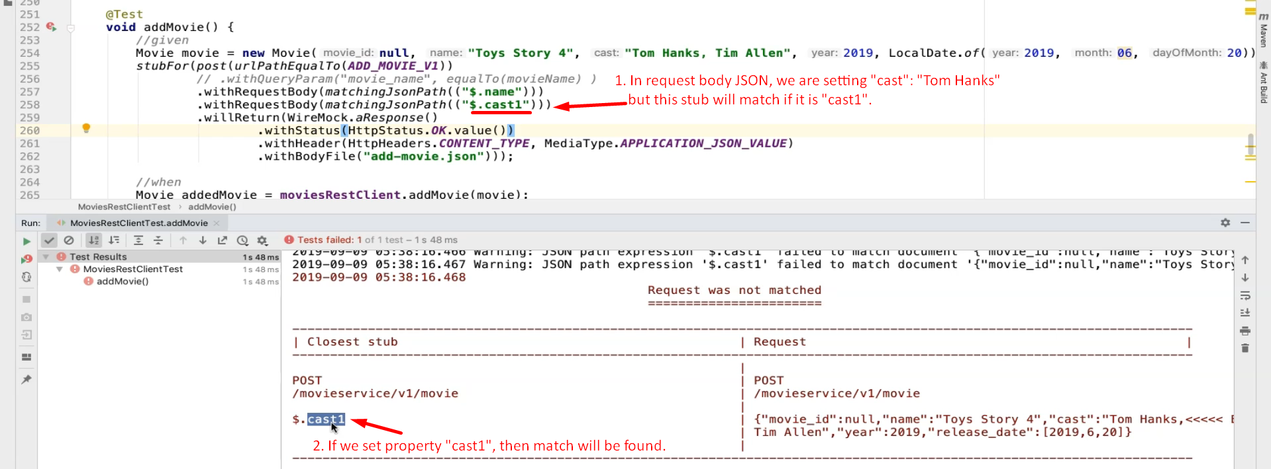
6. 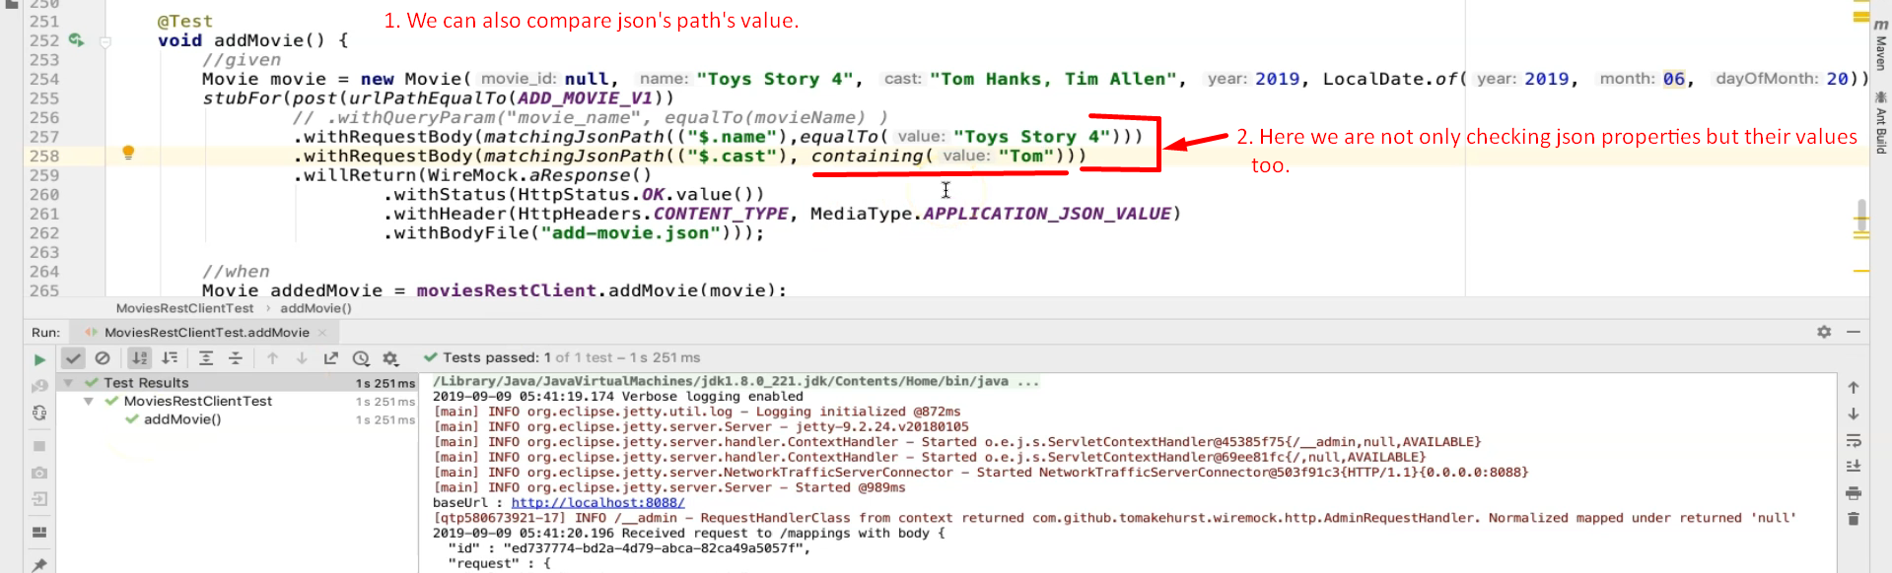
7. 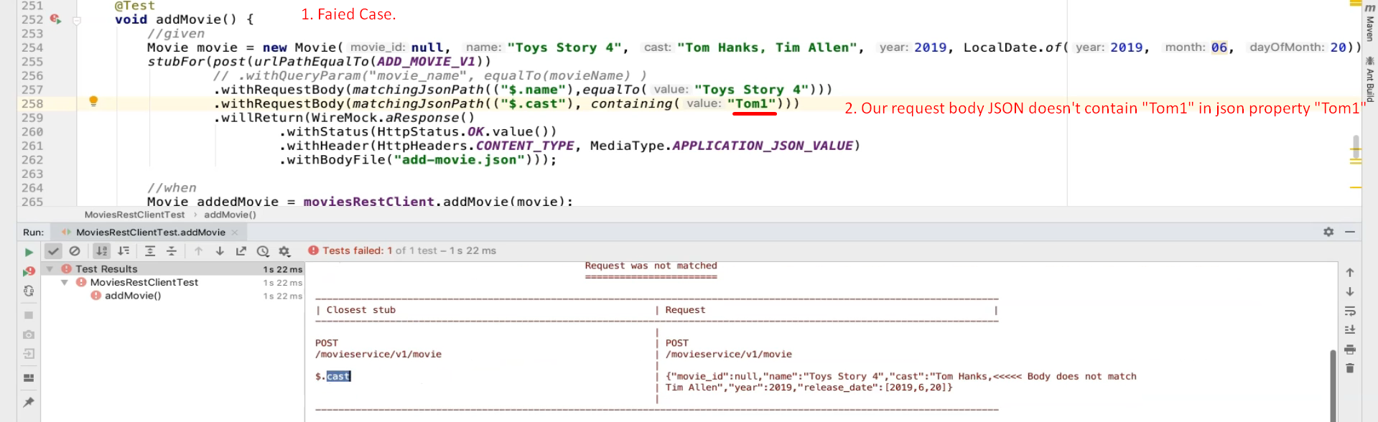
8.   
     
     
     
     
     
     
     
     
     
     
     
   We can also use REGEX.